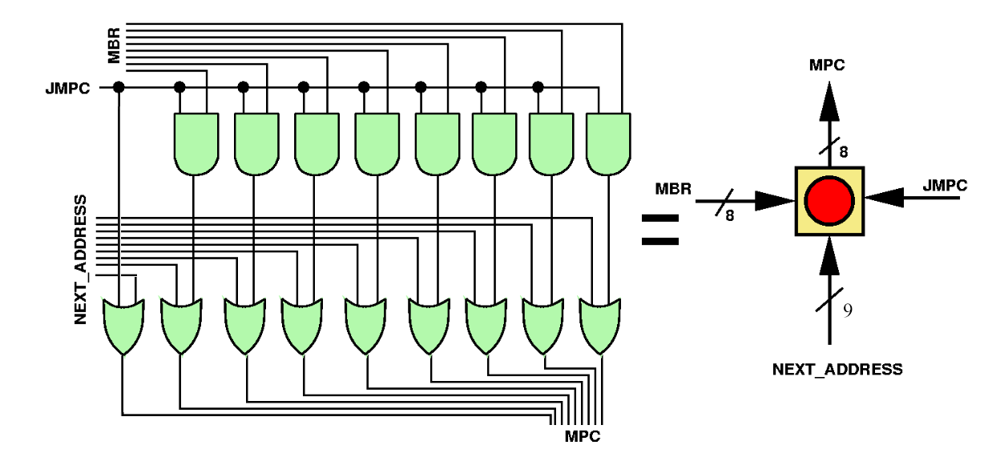1.

2.

a.

i = (j – n – 7) + (j – n – 7);

Values of j and n are loaded, and subtraction is done.

Now the value 7 is pushed in stack and subtracted.

Duplicate copy is pushed on the stack. So the original and duplicated are added to each other and then assigned to variable i.

b.

ILOAD – 6, IADD – 4, ISTORE – 7, ISUB – 4, BIPUSH – 4, DUP – 2

(6 + 6 + 4 + 4 + 4 + 2 + 4 + 7) \* 0.1*nsec* = 3.8*nsec*

3.